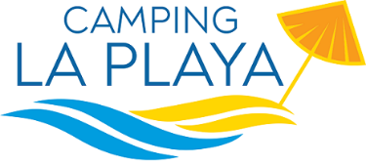

PRICES 2022

Camping | 01.06 - 30.06 | 01.07 - 31.07 23.08 - 31.08 | 01.08 - 22.08 | 01.09 - 19.09
YELLOW - pitch - electricity 3A | 13,00 | 15,00 | 22,00 | 12,00
BLUE - pitch - electricity 6A | 15,00 | 18,00 | 26,00 | 14,00
RED - pitch - electricity 6A | 20,00 | 22,00 | 30,00 | 19,00
GOLD- pitch- electricity 6A | 22,00 | 24,00 | 32,00 | 21,00
Small tent + electricity 3A | 7,00 | 8,00 | 11,00 | 6,00
Additional electricity + 3A | 3,00 | 3,00 | 3,00 | 3,00
Adults | 6,50 | 8,50 | 11,50 | 6,00
Children (2-8 years old) | 5,00 | 7,50 | 8,50 | 4,00
Car | 4,00 | 5,00 | 7,00 | 3,00
Motorbike | 3,00 | 4,00 | 5,00 | 2,00
Animals | 2,00 | 3,00  only Playa | 3,00  only Playa | 2,00
Visitors who stay more than one hour and leaves before 22.00 | 8,00 | 10,00 | 13,00 | 8,00
Caravan in bays without equipment | 30,00 | 35,00 | 45,00 | 25,00
€ 50,00 in case of the choice of a specific pitch number
City Tax € 1,50 per person per night (from 14 years old) for 10 days not included
OFFER FOR A MINIMUN STAY OF 7 NIGHTS
Yellow Pitch from 01.06 till 31/07 and from 01/09 till 19/09
DISCOUNT of 5% from the price list
STOP AND GO/12H Arrival h.20.00 Departure h.8.00 from the following day
2 adults + camper service + pitch + electricity
DISCOUNT of 20% from the price list
WEEKEND OFFERS
DISCOUNT of 10% in June-July-September (booking is compulsory) Arrival on Friday or Saturday - Departure on Sunday or Monday (by 20.00) 2 Nights – 3 Days

