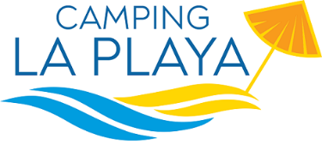

PRICES 2024

Camping | 30.05 - 30.06 01.09 - 08.09 | 01.07 - 02.08 26.08 - 31.08 | 03.8 – 25.08
YELLOW - pitch - electricity 3A | 13,00 | 15,00 | 23,00
BLUE - pitch - electricity 6A | 15,00 | 18,00 | 27,00
RED - pitch - electricity 6A | 20,00 | 22,00 | 31,00
GOLD – pitch – electicity 6A | 22,00 | 24,00 | 33,00
Small tent | 7,00 | 8,00 | 11,00
Additional electricity + 3A | 3,00 | 3,00 | 3,00
Adults | 7,00 | 9,50 | 12,50
Children (2-8 years old) | 5,00 | 7,50 | 9,00
Car | 4,00 | 5,00 | 7,00
Motorbike | 3,00 | 4,00 | 5,00
Animals | 2,00 | 3,00 | 5,00
Visitors who stay more than one hour and leaves before 22.00 | 10,00 | 12,00 | 15,00
Caravan in bays without equipment | 30,00 | 35,00 | 45,00
€ 50,00 in case of the choice of a specific pitch number
City Tax € 1,50 per person per night (from 14 years old) for 10 days not included
OFFER FOR A MINIMUN STAY OF 7 NIGHTS
YELLOW Pitch from 30/05 till 31/07 and from 01/09 till 08/09
DISCOUNT of 5% from the price list
STOP AND GO/12H Arrival h.20.00 Departure h.8.00 from the following day
2 adults + camper service + pitch + electricity
DISCOUNT of 20% from the price list

